SHAWN MENDES
TREAT YOU BETTER

Intro | Am | G | F | F |
| Am | G | F | F |

Verse | : Am | G | F | F |
| Am | G | F | F : | 2x

Chorus 1| Am | G | F | F |
2| Am | G | F | F |
3| Am | G | F | F |
4| Am | G | F | F |

Verse | : Am | G | F | F |
| Am | G | F | F : | 2x

Chorus 1| Am | G | F | F |
2| Am | G | F | F |
3| Am | G | F | F |
4| Am | G | F | F |

Gitaar | Am | G | F | F |
Loopje | Am | G | F | F |

Bridge | : Am | G | F | F |
| Am | G | F | F : | 2x

Chorus 1| Am | G | F | F |
2| Am | G | F | F |
3| Am | G | F | F |
4| Am | G | F | F |

Gitaar | Am | G | F | F |
Loopje | Am | G | F | F |

GITAAR AKKOORDEN

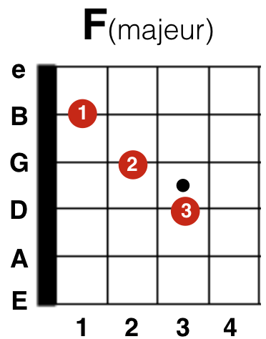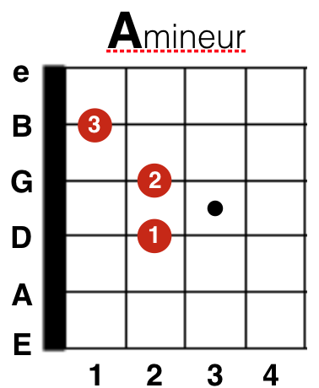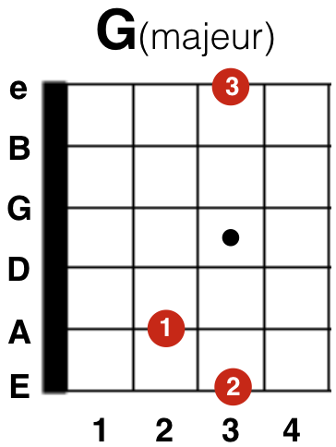

BAS AKKOORDEN

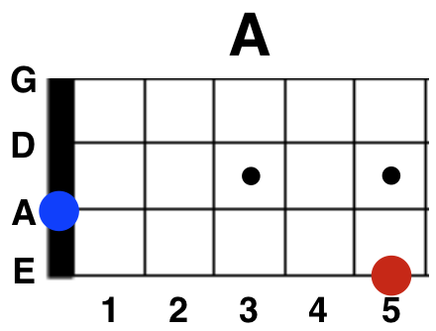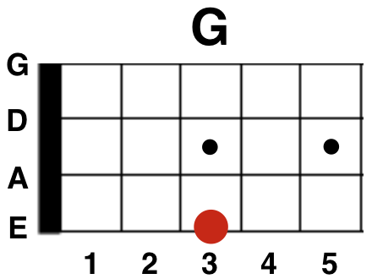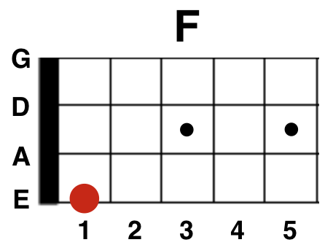

PIANO AKKOORDEN

