SHAWN MENDES
STITCHES

Intro | Am | G | C | F |

Verse | : Am | G | C | F |
| Am | G | C | F : | 2x

Pre-Chorus | Am | G | C | F |
| Am | G | C | F |

Chorus 1| Am | G | C | F |
2| Am | G | C | F |
3| Am | G | C | F |
4| Am | G | C | F |

Verse | : Am | G | C | F |
| Am | G | C | F : | 2x

Pre-Chorus | Am | G | C | F |
| Am | G | C | F |

Chorus 1| Am | G | C | F |
2| Am | G | C | F |
3| Am | G | C | F |
4| Am | G | C | F |

Intro | Am | G | C | F |

Bridge | : Am | G | C | F |
| Am | G | C | STOP : | 2x

Chorus 1| Am | G | C | F |
2| Am | G | C | F |
3| Am | G | C | F |
4| Am | G | C | F |

Outro | Am | G | C | F |
| Am | G | C | F |

SHAWN MENDES
STITCHES

GITAAR AKKOORDEN

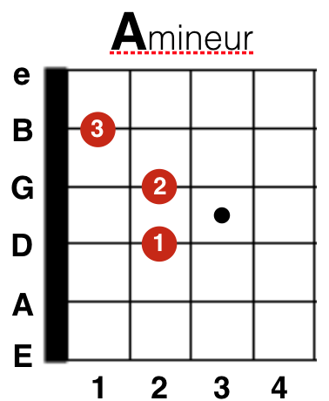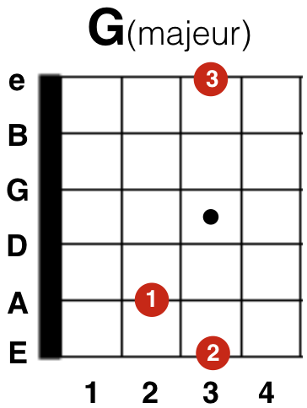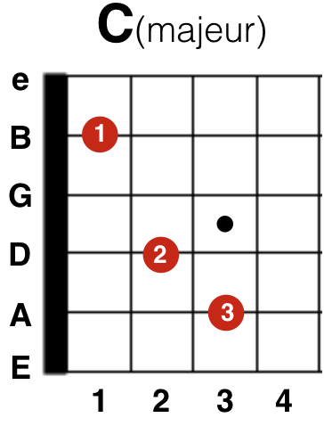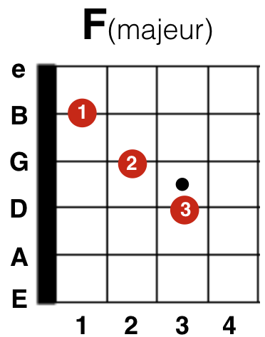

BAS AKKOORDEN

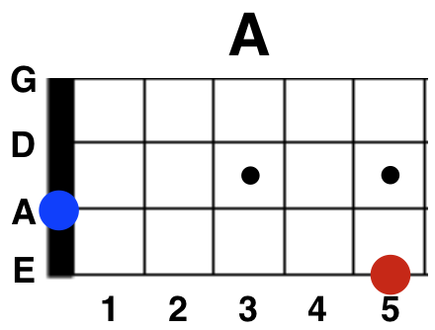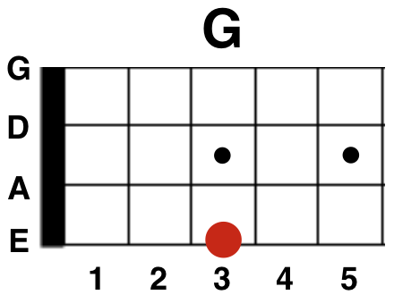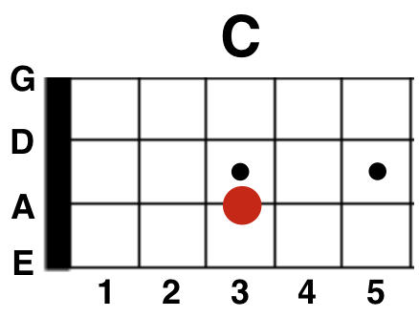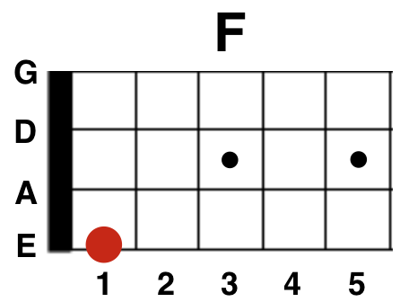

PIANO AKKOORDEN

