THE ROLLING STONES
ANGIE
AKKOORDENSCHEMA

INTRO | Am | E7 | G F | C |

COUPLET | Am | E7 | G F | C |
| Am | E7 | G F | C |

REFREIN | G | Dm Am | C F | G |
| Am | E7 | G F | C |

COUPLET | Am | E7 | G F | C |
| Am | E7 | G F | C |

REFREIN | G | Dm Am | C F | G |
| Am | E7 | G F | C |

INSTR. | Am | E7 | G F | C |
| Am | E7 | G F | C |

REFREIN | G | Dm Am | C F | G |
| Am | E7 | G F | C |

INSTR. | Am | E7 | G F | C |

REFREIN | G | Dm Am | C F | G |

BRIDGE | Dm | Am | Dm | Am |
| Dm | Am | C F | G |

OUTRO | Am | E7 | G F | C |
| Am | E7 | G F | C |

THE ROLLING STONES
ANGIE
AKKOORDEN

GITAAR AKKOORDEN
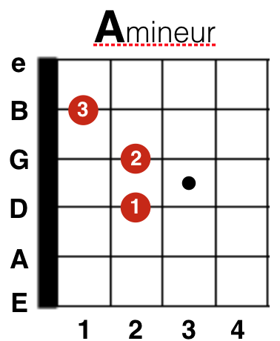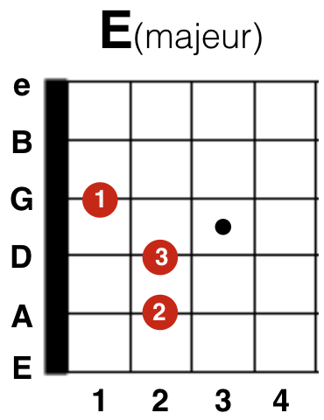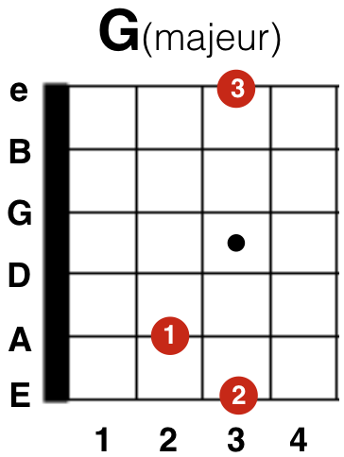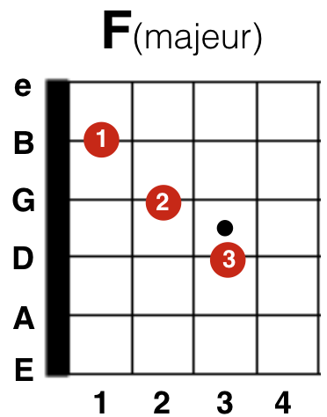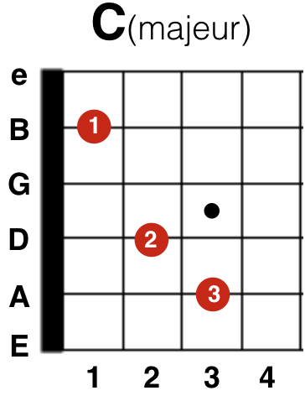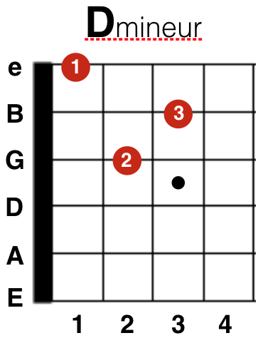

BASNOTEN
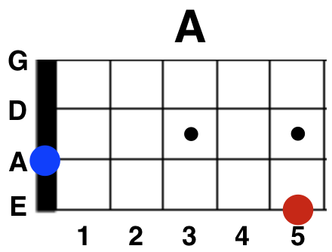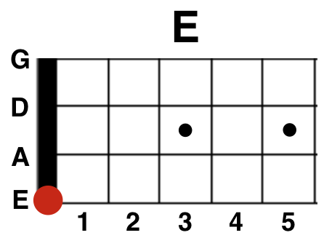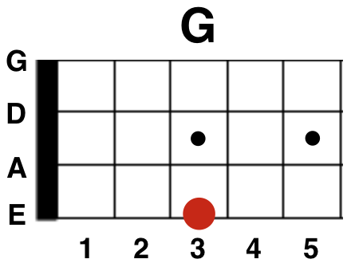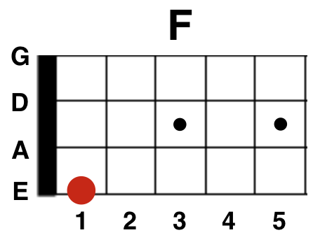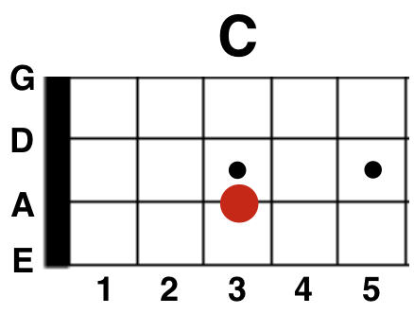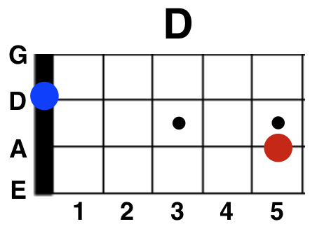

PIANO AKKOORDEN
